Grade: First |  | Unit: Length
Quarter Taught: Q4 |  | Duration of Unit: 6-9 days
PLC Question: What do we want all students to know and be able to do?
Smart Goal for the Cycle:
By the end of the cycle, of the students will demonstrate mastery of the standards included in the cycle, and all will demonstrate growth.
Vocabulary: ⬜endpoint ⬜length ⬜longer ⬜shorter
3.0 and 2.0 Content for Unit
(Use full teacher NAD Proficiency Scales when planning and instructing.)
3.0 | ⬜ Order three or more objects by length. (1.L1, BIM 10.1, 10.2)  ⬜ Measure the length of an object as a number of length units. (1.L2, BIM 10.3, 10.4)
2.0 | ⬜ Describe the length of an object as the distance between its endpoints. (1.L1, BIM 10.1, 10.2)  ⬜ Indirectly compare the length of two objects. (1.L1, BIM 10.1, 10.2)  ⬜ Explain that when a series of objects are placed in order from shortest to longest, each object  will be longer than those that come before it and shorter than those that come after it. (1.L1, BIM 10.1, 10.2)  ⬜ Arrange a series of length-unit manipulatives (inch cubes, centimeter cubes) along an object to  be measured such that the length units iterate from one endpoint of the object to the other  without gaps or overlaps. (1.L2, BIM 10.3, 10.4)  ⬜Express the length of an object as a number of length units. (1.L2, BIM 10.3, 10.4)

Evidence of Learning
PLC Question: How will we know when students have learned?
Day 1: Pre-assessment  Day 3: Length Gallery Walk  Day 5: Measurement Activity (Have students choose  10 different items to measure, such as pencils,  crayons, books, etc.)  Day 7: End of Unit Assessment | Other:  ⬜Observation  ⬜Manipulatives  ⬜Student Portfolio  ⬜Define Vocabulary Terms  ⬜Other: _________________

Learning Supports
PLC Question: What will we do when students have not learned?
Supports Options: ⬜ Rulers ⬜ Yardsticks ⬜ Anchor charts created by students ⬜ Stories about length ⬜ Video clips ⬜ Songs
Common Errors:
- Students start measuring an object or a line on their textbooks by starting on one, instead of 0. Use rulers that have the 0 marked on the ruler.
Re-teaching Strategies:  ⬜Learning centers (see BIM, T-538)  ⬜Connect 10 paper clips. Use those paperclips to  measure things around the room.  ⬜Peer-assisted instruction  ⬜Online Big Ideas Math > Resources > Resources By  Chapter  ⬜Other _____________________________ | Re-assessment Strategies:  ⬜Exit tickets  ⬜Brain dumps  ⬜Student conferences  ⬜Choice board  ⬜PBL  ⬜Online Quiz (Kahoot, Quizziz)  ⬜Other _____________________________

Enrichment and Extension Ideas
PLC Question: What will we do when students already know it?
4.0 | ⬜ Determine the difference in length measurements between two objects measured with the same length units.
- BIM Lesson 10.5 matches the 4.0 element on the proficiency scale for length.

Daily Lesson Plans
PLC Question: How will we facilitate student learning?
Curriculum Resources: Big Ideas Math: Modeling Real Life, Grade 1 ©2019
Correlated BIM Lessons: 10.1-10.4
Additional Resources: IXL (connect Skill Plans for 2019 Big Ideas), https://www.didax.com/math/virtual-manipulatives.html, https://www.mathlearningcenter.org/apps
Day 1 | Day 2 | Day 3 | Day 4 | Day 5
⬜ Pre-Assessment (attached)  ⬜ Teach attached Vocabulary (review throughout unit)  ⬜ Introduce P-Scales and I Can Statements (attached) | ⬜ Order Objects by Length  (BIM 10.1) | ⬜ Compare Lengths Indirectly (BIM 10.2)  ⬜ Check for Understanding (Length Gallery Walk attached) | ⬜ Measure Lengths (BIM 10.3) | ⬜ Measure Lengths (BIM 10.3)  ⬜ Check for Understanding (Measurement Activity)
Day 6 | Day 7 | Day 8 | Day 9
⬜ Measure More Lengths (BIM 10.4) | ⬜ End of Unit Assessment | ⬜ Reteach/ Enrich/ Extend Activities | ⬜ Reteach/ Enrich/ Extend Activities

The following documents are created via Canva
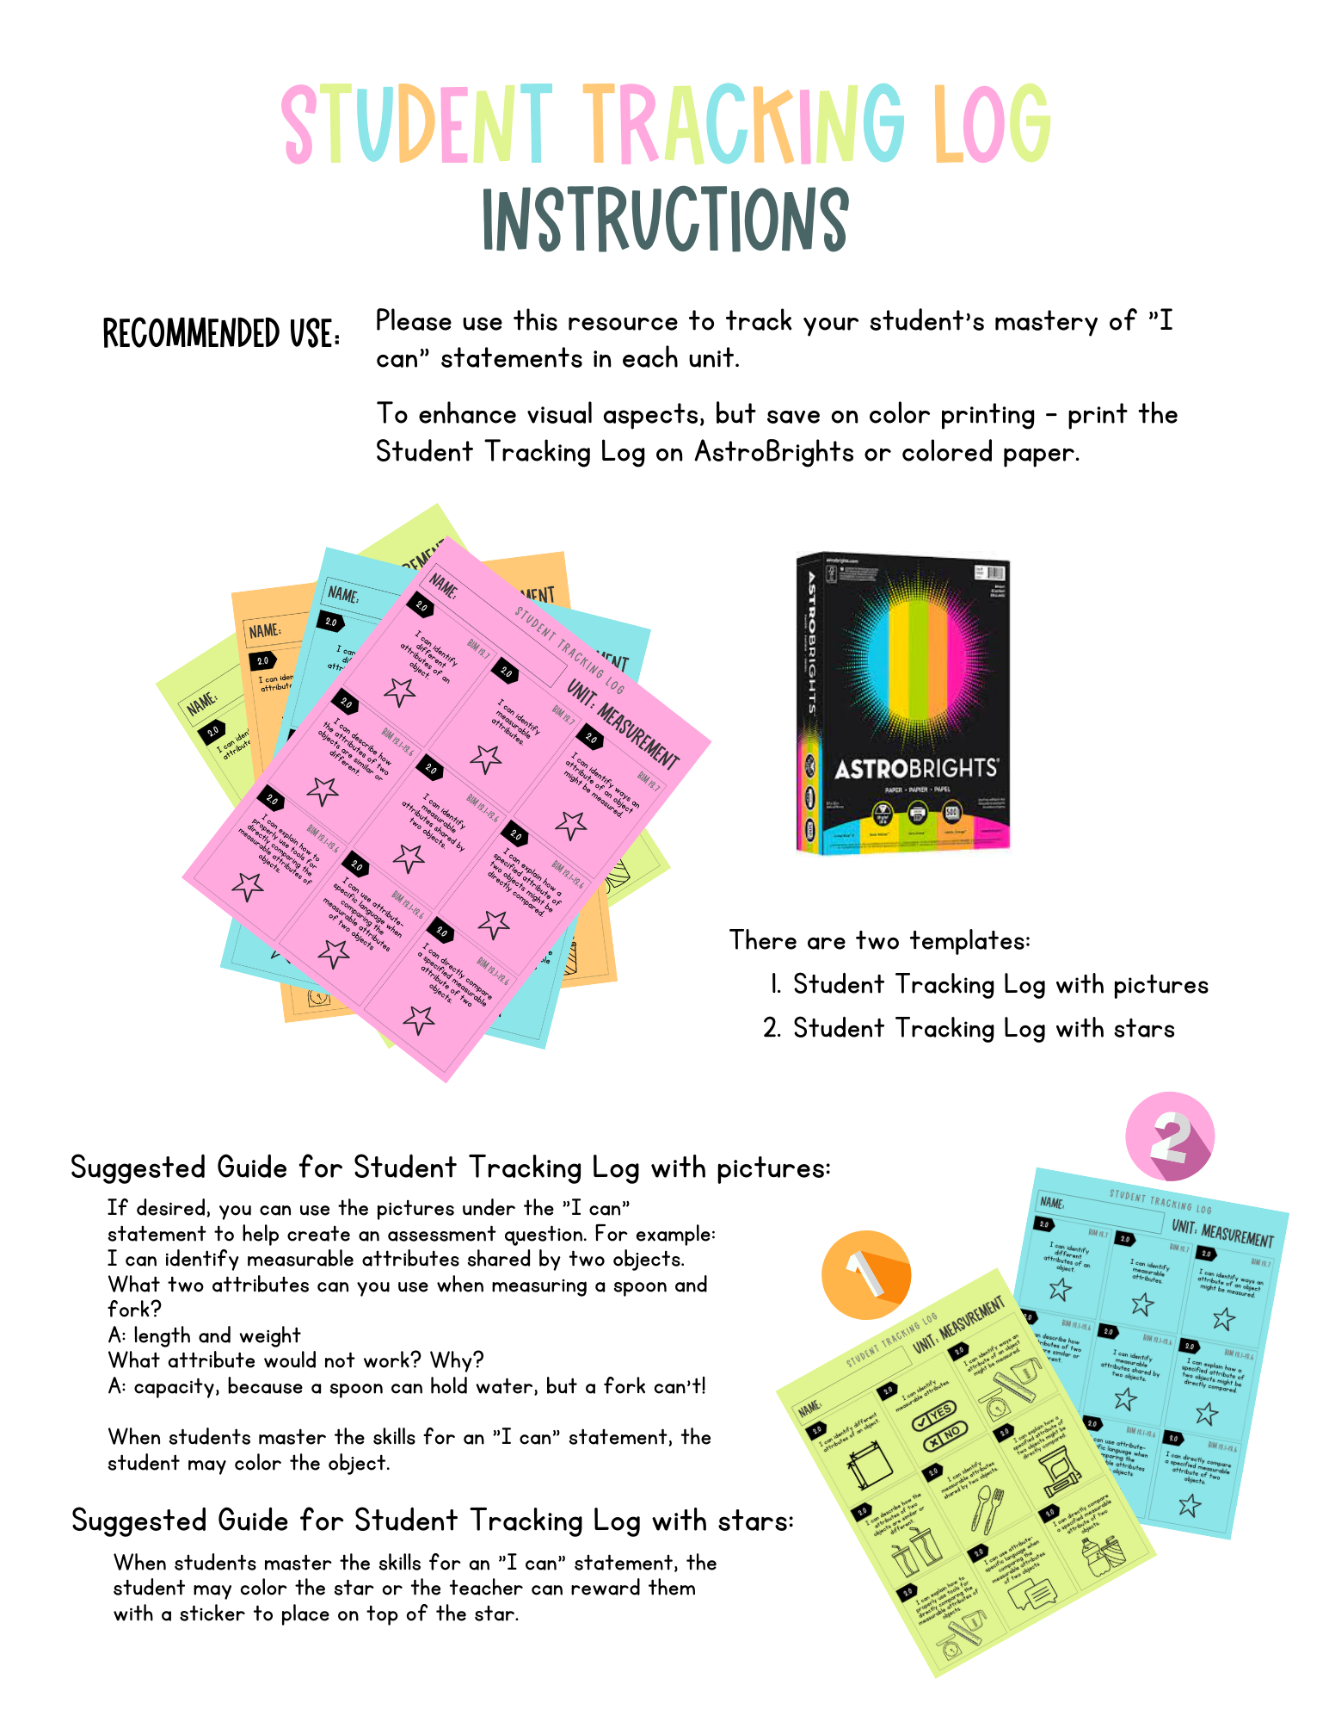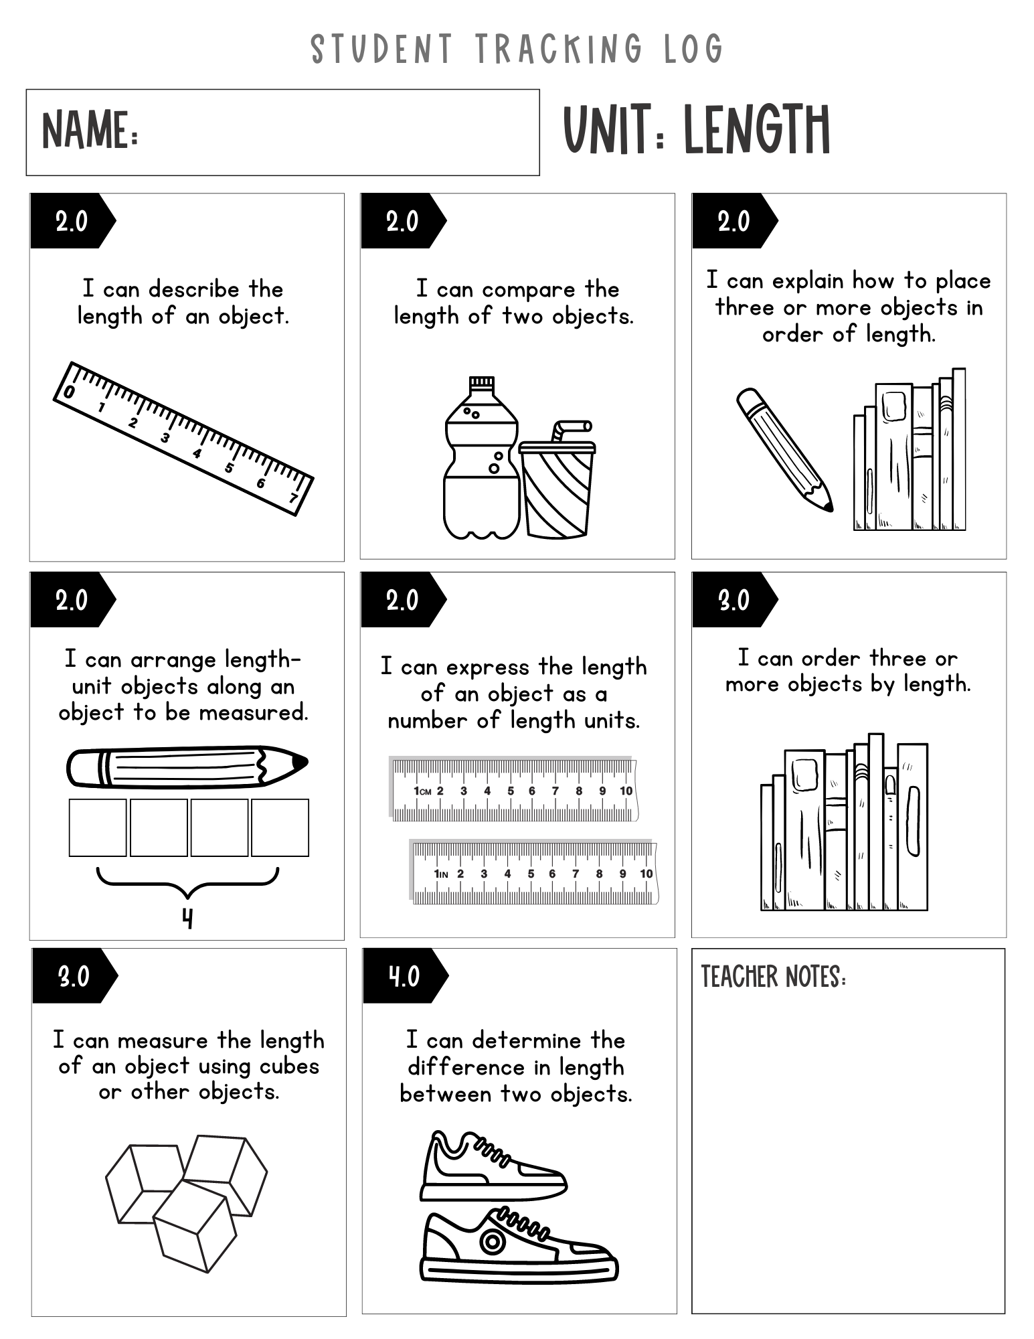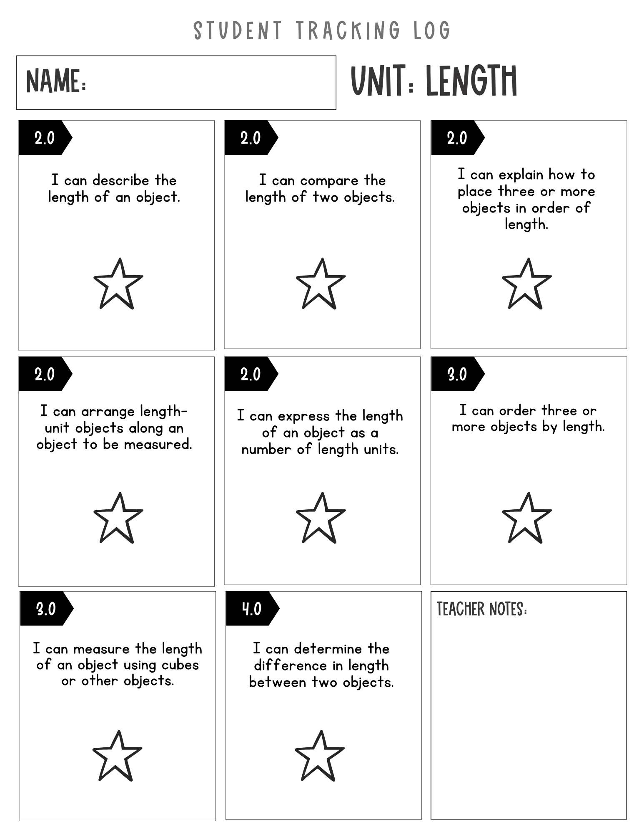
End of the documents created via Canva

Vocabulary Cards

Endpoint

Length

Longer

Shorter

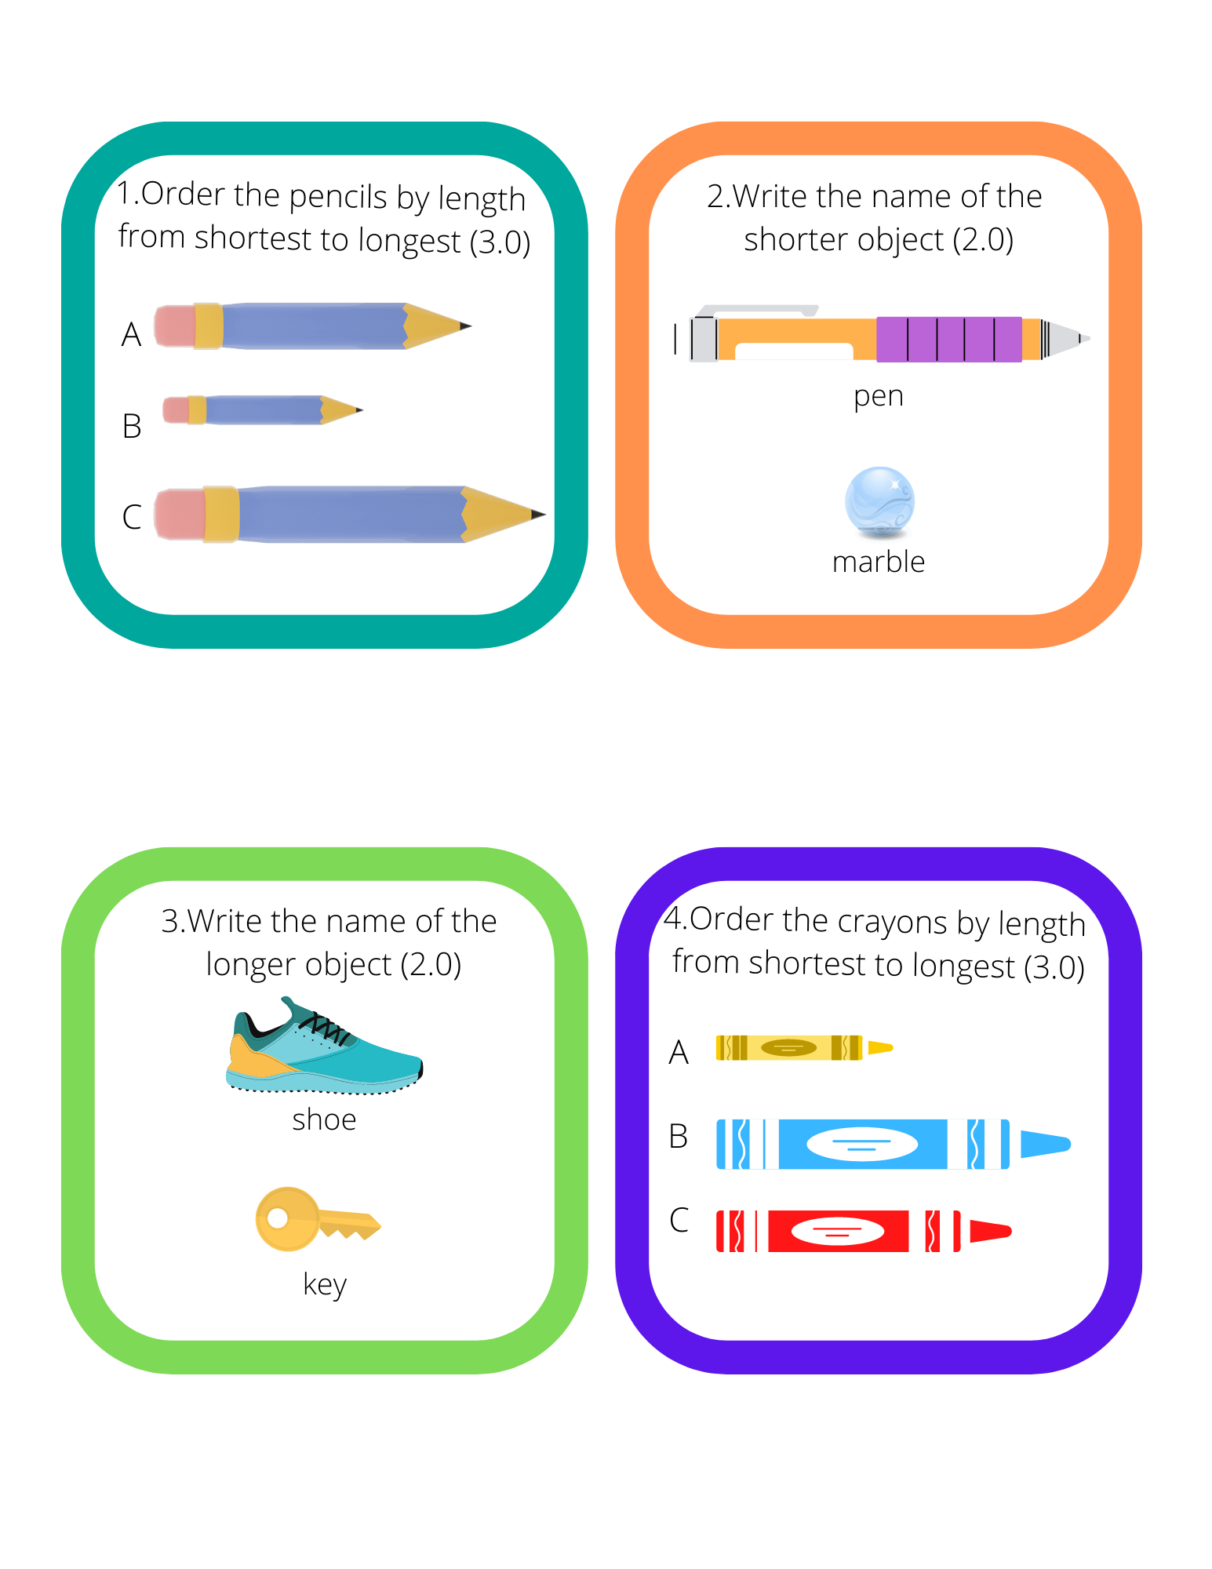
Gallery Walk

Created via Canva
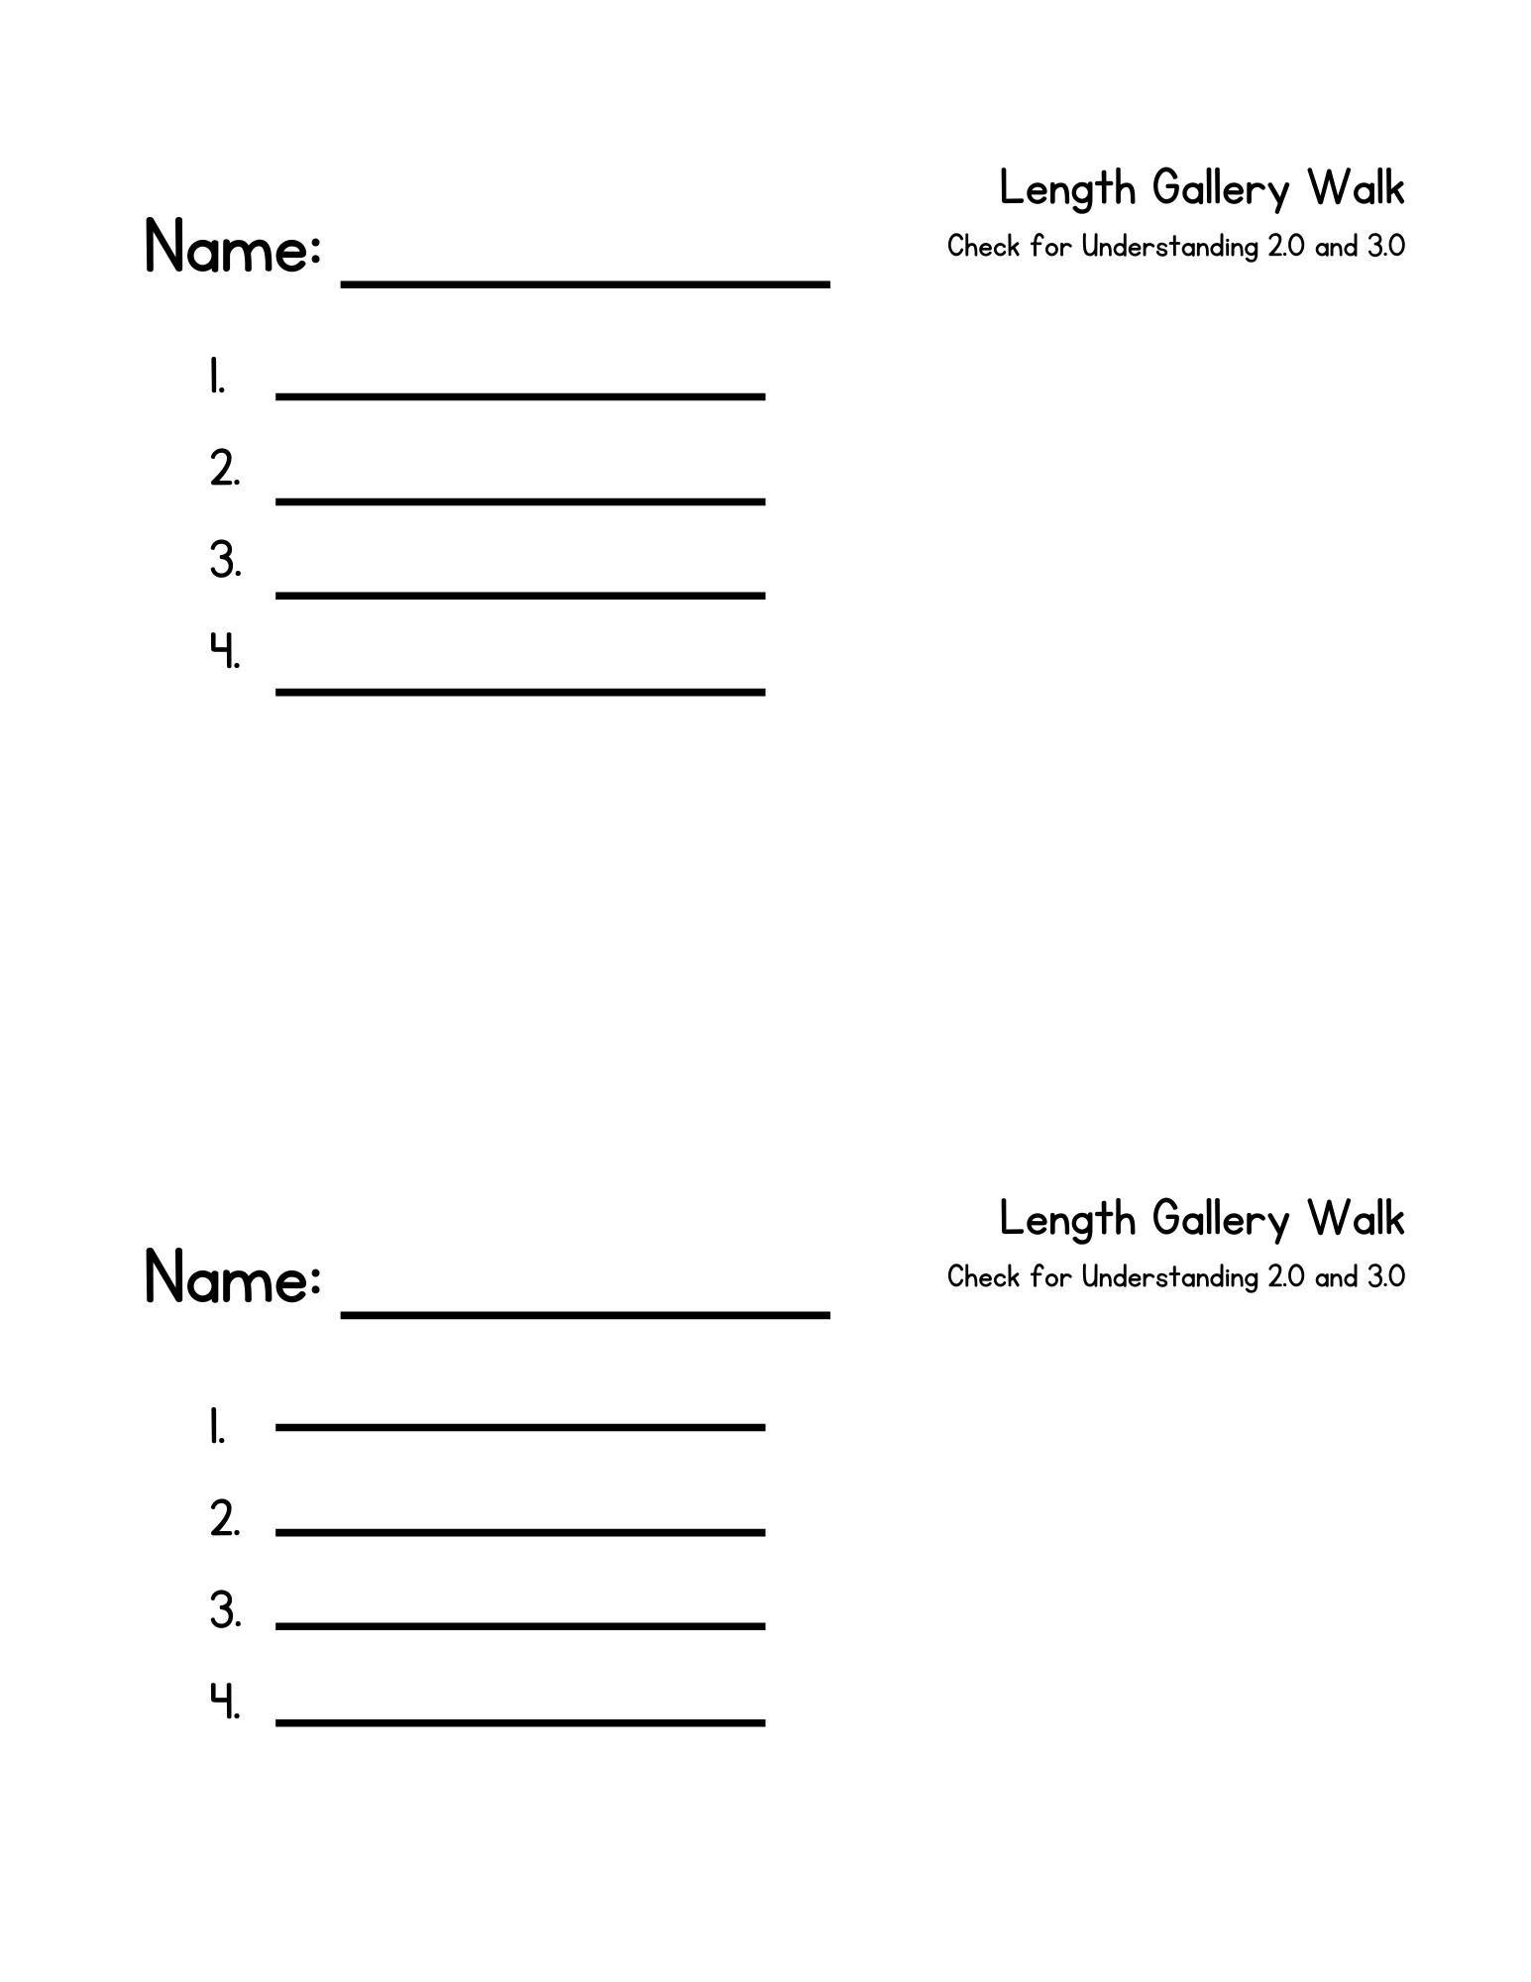

Created via Canva
